**Weekly Excel Hacks**

<https://www.youtube.com/watch?v=2-xbU7J57n4&list=PLS7iHfqXNVhJvdFXgsZlfZeAXptzzSwET&index=1>

**F4** or **Ctrl + Y** – repeats the last action

**Ctrl + '** – copies the formula from the cell above or next to it

|  |  |  |  |
| --- | --- | --- | --- |
| **Date** | 12/16/2014 |  | **Ctrl + ;** |
| **Time** | 10:00 PM |  | **Ctrl + Shift + ;** |
| **Date and time** | 12/16/2014 22:00 |  | **Ctrl + ; <space> Ctrl + Shift + ;** |

**'===========================================================================**

**'Weekly Excel Hacks - Episode 01**

**'===========================================================================**

<https://www.youtube.com/watch?v=2-xbU7J57n4&list=PLS7iHfqXNVhJvdFXgsZlfZeAXptzzSwET&index=1>

'Function to use in the cell which takes a range and returns the colorindex of the cell

Public Function ColorIndex(ByVal aRange As range)

ColorIndex = aRange.Interior.ColorIndex

End Function

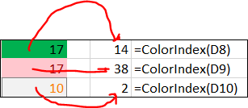

**'===========================================================================**

**'Weekly Excel Hacks - Episode 02**

**'===========================================================================**

<https://www.youtube.com/watch?v=tpgtqRCcxBs&list=PLS7iHfqXNVhJvdFXgsZlfZeAXptzzSwET&index=2>

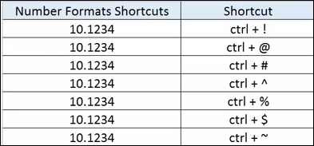

Weekly Excel Hacks - Episode 05

<https://www.youtube.com/watch?v=_our7MgxyQM&index=5&list=PLS7iHfqXNVhJvdFXgsZlfZeAXptzzSwET>

1. Select several cells
2. Input a value in the first cell in the selection
3. Press Ctrl + Enter to replicate the same value to all the cells in the selected range

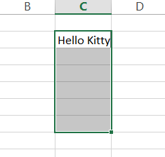

**Press Ctrl + Enter**

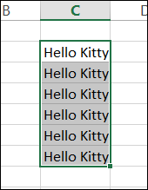

To make cursor "rolled" while in executing mode

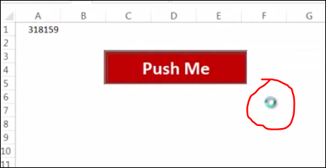

'===========================================================================

'Weekly Excel Hacks - Episode 05

'===========================================================================

REM https://www.youtube.com/watch?v=_our7MgxyQM&index=5&list=PLS7iHfqXNVhJvdFXgsZlfZeAXptzzSwET

'To make the cursor the have a "circled" shape while being in the executing mode

Sub clickMe()

Dim x As Double

**Application.Cursor = xlWait**

On Error GoTo myError

With ThisWorkbook.Sheets("Sheet1")

For x = 1 To 1000 Step 0.01

.Cells(1, 1).Value = .Cells(1, 1).Value + 1

.Cells(2, 1).Value = x

Next x

End With

myError:

**Application.Cursor = xlDefault**

End Sub

'===========================================================================

'Weekly Excel Hacks - Episode 06

'===========================================================================

REM <https://www.youtube.com/watch?v=At0q3r-ATkg&list=PLS7iHfqXNVhJvdFXgsZlfZeAXptzzSwET&index=6>

Ctrl + Shify + F3 -- assign named ranges based on the column names from the table

To represent fractions, e.g. 1/3, put in the cell a zero, space, and a fraction --> 0 1/3, 0 7/8

